**Task 3**

**Extra Credit Problem**

**ExtraCredit_Facts.txt (S1)**

(A ttt1)

(B ttt1)

(C ttt1)

(preconds

(ppp1 B C)

(ppp2 A)

(ppp2 B)

(ppp3 C)

)

(effects

(eee1 A C)

(eee2 C)

(eee3 C)

(eee3 A)

)

**ExtraCredit_Ops.txt**

(operator

aaa

(params

(<b> ttt1) (<c> ttt1))

(preconds

(ppp1 <b> <c>) (ppp2 <b>) (ppp3 <c>))

(effects

(eee1 <b> <c>) (eee2 <b>) (del eee2 <c>) (del eee3 <c>)))

**Output**

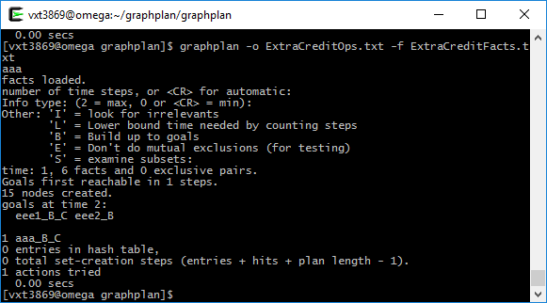

After executing changes will be in effects of S1, ‘eee2 C’ & ‘eee3 C’ will get deleted and ‘eee1 B C’ & ‘eee2 B’ will be added. Objects and preconds will be same.

(effects

(eee1 A C) (eee1 B C) (eee2 B) (eee3 A))